NEWSLETTER

LOGO HERE

DECEMBER 2024
Name of your community, address, phone number



IN THIS ISSUE

Editor’s Desk 2
Month in Review 3
Upcoming Events 5
December Calendar 6
December Birthdays ………..………. 7

Comic Strip …………….………………. 8
Noticeboard 9

Spotlight 10
Word Search 11

munity


EDITOR’S DESK

Hello Residents, Families and Friends!

Lorem Ipsum is used in publishing to show where a block of text should be by using random english-looking words. The rest of this paragraph will be Lorem Ipsum.

Lorem ipsum dolor sit amet, consectetur adipiscing elit, sed do eiusmod tempor incididunt ut labore et dolore magna aliqua. Ut enim ad minim veniam, quis nostrud exercitation ullamco laboris nisi ut aliquip ex ea commodo
consequat.

Duis aute irure dolor in reprehenderit in voluptate velit esse cillum dolore eu fugiat nulla pariatur. Excepteur sint occaecat cupidatat non provident.

Keep Safe!
YOUR NAME
QUOTE OF THE DAY
- Guinean Proverb

“Knowledge without wisdom
is like water in the sand.”


DECEMBER TRIVIA
December is the only month of the year that can begin and end on the same day of the week in common years. In other words, if December 1st falls on a Tuesday, then December 31st will also be a Tuesday.
Sagittarius (November 22 – December 21)
Capricorn (December 22 – January 19)
Turquoise – December Birthstone

MONTH IN REVIEW (LAYOUT 1)


ACTIVITY SPOTLIGHT 1

Lorem ipsum dolor sit amet, consectetur adipiscing elit, sed do eiusmod tempor incididunt ut labore et dolore magna aliqua. Ut enim ad minim veniam, quis nostrud exercitation ullamco laboris nisi ut aliquip ex ea commodo consequat.

Duis aute irure dolor in reprehenderit in voluptate velit esse cillum dolore eu fugiat nulla pariatur. Excepteur sint occaecat cupidatat non provident.

ACTIVITY SPOTLIGHT 1
Lorem ipsum dolor sit amet, consectetur adipiscing elit, sed do eiusmod tempor incididunt ut labore et dolore magna aliqua. Ut enim ad minim veniam, quis nostrud exercitation ullamco laboris nisi ut aliquip ex ea commodo consequat.

Duis aute irure dolor in reprehenderit in voluptate velit esse cillum dolore eu fugiat nulla pariatur. Excepteur sint occaecat cupidatat non provident.

ACTIVITY SPOTLIGHT 1

Lorem ipsum dolor sit amet, consectetur adipiscing elit, sed do eiusmod tempor incididunt ut labore et dolore magna aliqua. Ut enim ad minim veniam, quis nostrud exercitation ullamco laboris nisi ut aliquip ex ea commodo consequat.

Duis aute irure dolor in reprehenderit in voluptate velit esse cillum dolore eu fugiat nulla pariatur. Excepteur sint occaecat cupidatat non provident.

MONTH IN REVIEW (LAYOUT 2)

COMMENT ABOUT PHOTO COMMENT ABOUT PHOTO

COMMENT ABOUT PHOTO COMMENT ABOUT PHOTO

COMMENT ABOUT PHOTO COMMENT ABOUT PHOTO

UPCOMING EVENTS


Ladies Morning Tea
Tuesday 3rd December 10:30am, Dining Room

Resident’s Meeting
Saturday 7th December 2:00pm, Recreation Area

Left-handers Games

Sunday 8th December 2:00pm, Recreation Area

Armchair Travel
Sunday 15th December 10:00am, Recreation Area

Multicultural Day
Friday 27th December 2:00pm, Recreation Area

High Tea

Saturday 28th December 2.00pm, Dining Room

REGULAR EVENTS


Happy Hour
Every Friday 5 PM

Catholic Service
Every Tuesday 8:.45 AM

Hairdresser
Every second Monday from 1:30 PM

Men’s Group
Every second Thursday at 2 PM

Bingo!
Every day at 10 PM
HOLIDAYS CELEBRATED IN DECEMBER
- December 6 – Saint Nicholas Day
- December 25 – Christmas Day
- December 26 – Boxing Day
- December 26 to January 1 – Kwanzaa
- December 31 – New Year’s Eve
- Typically in December – Hanukkah

DECEMBER 2024

SUNDAY | MONDAY | TUESDAY | WEDNESDAY | THURSDAY | FRIDAY | SATURDAY
1. | 2. | 3. | 4. | 5. | 6. | 7.
8. | 9. | 10. | 11. | 12. | 13. | 14.
15. | 16. | 17. | 18. | 19. | 20. | 21.
22. | 23. | 24. | 25. | 26. | 27. | 28.
29. | 30. | 31.

Add Text Here

DECEMBER BIRTHDAYS




IN DECEMBER, WE CELEBRATE BIRTHDAYS WITH:


NAME HERE | NAME HERE | NAME HERE | NAME HERE
Date | Date | Date | Date

Please join us in the recreation room on the first Sunday in December to celebrate!
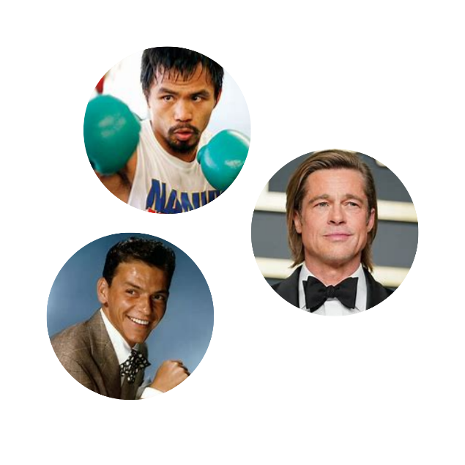

DECEMBER'S ICONS:
CELEBRATING THE BIRTHDAYS OF LEGENDARY FIGURES
- BRAD PITT – DECEMBER 18, 1963 – ACTOR AND FILMMAKER
- LEBRON JAMES – DECEMBER 30, 1984 – BASKETBALL PLAYER
- FRANK SINATRA – DECEMBER 12, 1915 – SINGER AND ACTOR
- WALT DISNEY – DECEMBER 05, 1901 – FILM PRODUCER
- STAN LEE – DECEMBER 28, 1922 – COMIC BOOK WRITER
- JANE AUSTEN – DECEMBER 16, 1775 – NOVELIST
- MANNY PACQUIAO – DECEMBER 17, 1978 – BOXER
- NOAM CHOMSKY – DECEMBER 07, 1928 – LINGUIST AND PHILOSOPHER
- POPE FRANCIS – DECEMBER 17, 1936 – 266TH POPE OF THE CATHOLIC CHURCH
- KATE SPADE – DECEMBER 24, 1962 – FASHION DESIGNER


Sagittarius individuals have a strong sense of wanderlust and love for travel. They are known as adventurers and tends to have a natural curiosity about the world and a deep desire to explore new places, cultures, and experiences.
Capricorns have a strong sense of connection to the element of earth in astrology. This signifies practicality and a grounded approach to life.
December is the twelfth month in a year. However, it was originally the tenth month of the year in the Roman Calendar. Its name is derived from the Latin word ‘decem’ meaning ‘ten’.

COMIC STRIP
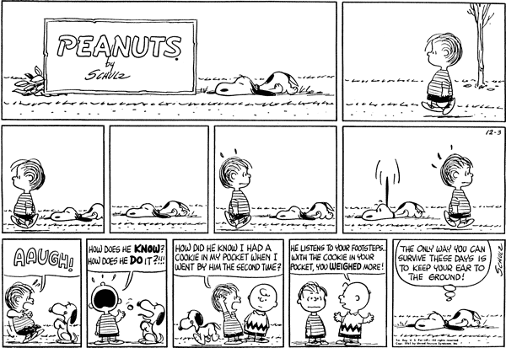

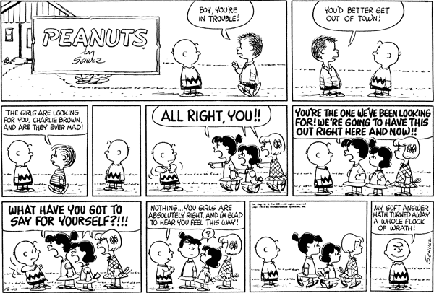
NOTICEBOARD
NAME HERE
NAME HERE
NAME HERE
NAME HERE
NAME HERE
NAME HERE
NAME HERE
NAME HERE
NEW RESIDENTS
A VERY WARM WELCOME TO:
NEW STAFF
WE EXTEND A HEARTFELT WELCOME TO THOSE WHO HAVE RECENTLY JOINED OUR TEAM

ONGOING ENHANCEMENT
ONGOING ENHANCEMENT

CONTINUOUS IMPROVEMENT PLAN
CONTINUOUS IMPROVEMENT PLAN

Lorem ipsum dolor sit amet, consectetur adipiscing elit, sed do eiusmod tempor incididunt ut labore et dolore magna aliqua. Ut enim ad minim veniam, quis nostrud exercitation ullamco laboris nisi ut aliquip ex ea commodo consequat.

Lorem ipsum dolor sit amet, consectetur adipiscing elit, sed do eiusmod tempor incididunt ut labore et dolore magna aliqua. Ut enim ad minim veniam, quis nostrud exercitation ullamco laboris nisi ut aliquip ex ea commodo consequat.

Lorem ipsum dolor sit amet, consectetur adipiscing elit, sed do eiusmod tempor incididunt ut labore et dolore magna aliqua. Ut enim ad minim veniam, quis nostrud exercitation ullamco laboris nisi ut aliquip ex ea commodo consequat.

Lorem ipsum dolor sit amet, consectetur adipiscing elit, sed do eiusmod tempor incididunt ut labore et dolore magna aliqua. Ut enim ad minim veniam, quis nostrud exercitation ullamco laboris nisi ut aliquip ex ea commodo consequat.

ANNOUNCEMENT
TITLE HIGHLIGHTS
ANNOUNCEMENT
TITLE HIGHLIGHTS

STAFF & RESIDENT PERSON



TITLE HERE

[STORY HERE] Lorem ipsum dolor sit amet, consectetur adipiscing elit, sed do
eiusmod incididunt ut labore et dolore magna aliqua. Ut enim ad minim veniam, quis
tempor nostrud exercitation ullamco laboris nisi ut aliquip ex ea commodo consequat
Lorem ipsum dolor sit amet, consectetur adipiscing elit, sed do eiusmod tempor

incididunt ut labore et dolore magna aliqua. Ut enim ad minim veniam, quis
nostrud exercitation ullamco laboris nisi ut aliquip ex ea commodo consequat Ut
enim ad minim veniam, quis nostrud exercitation ullamco laboris nisi ut aliquip ex ea commodo consequat Lorem ipsum dolor sit amet, consectetur adipiscing elit, sed do
eiusmod tempor

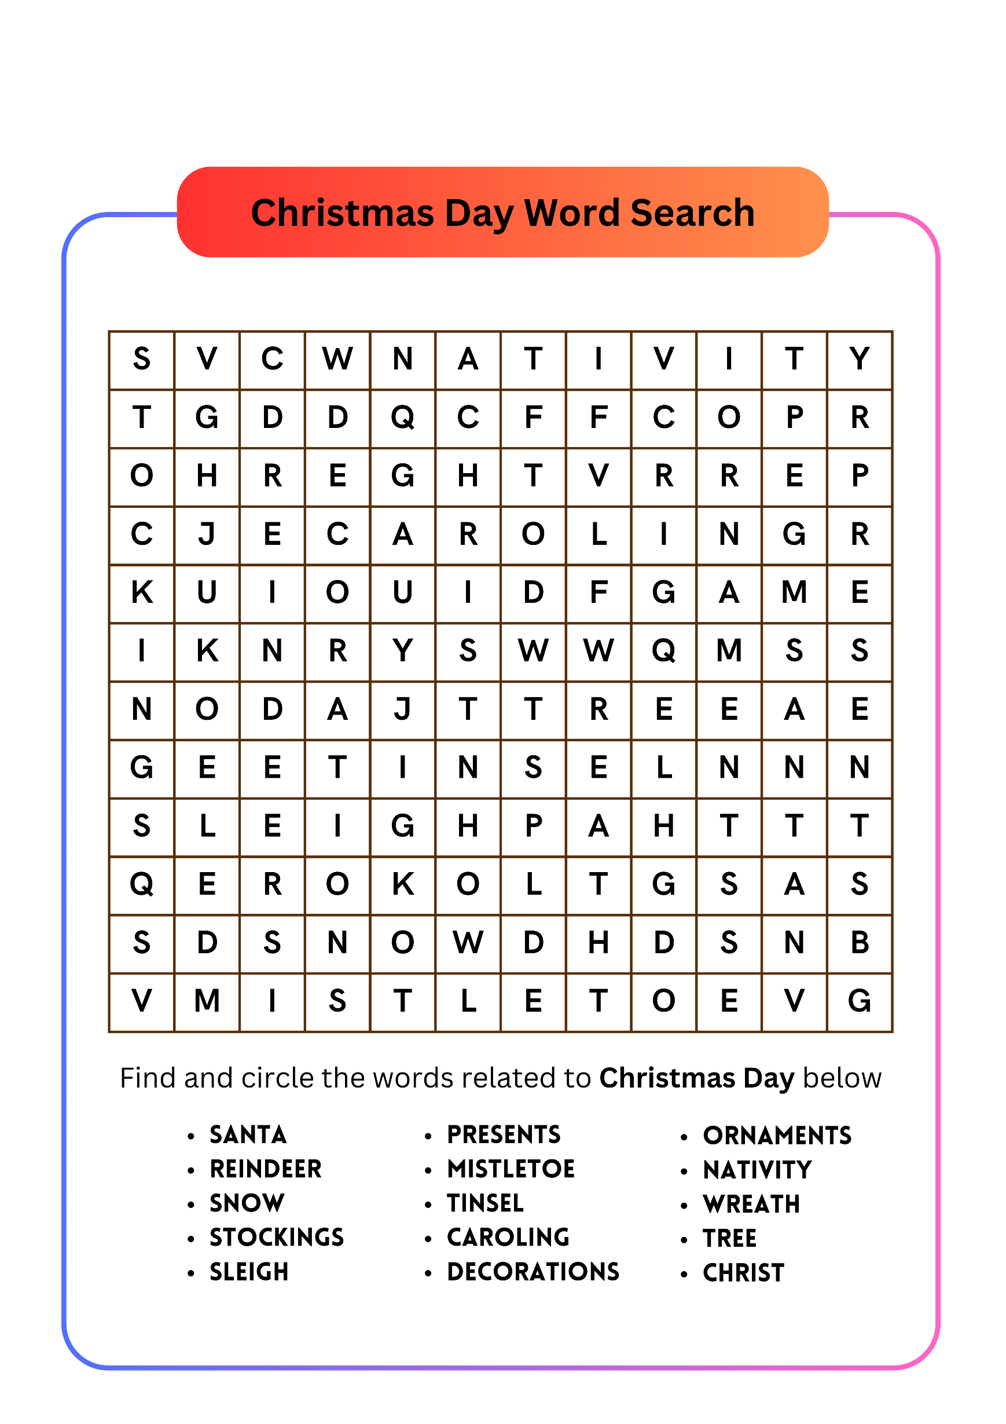
WORD SEARCH PUZZLE

